First we have to write a solidity contract for our lottery app in remixMD

Deploy the contract

Successfully deploying

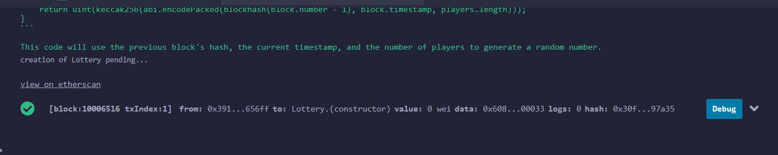

Contract address: 0x12b9302F44b504863728A97b4a3C2a3B0c075d20

Creating a blank npx app

Installing ethers

Creating constants for the project:

